MODULE – B

Asset Definition: provide AssetType and AssetDefinition tables with records

1. ADDING NEW ASSET TYPE

ENDPOINT: POST-> <http://localhost:9090/api/assetTypes>

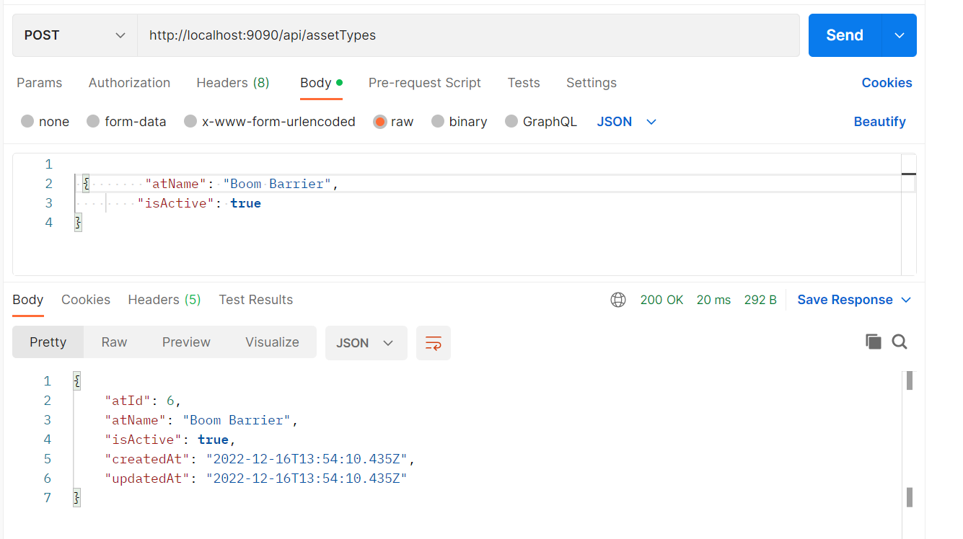

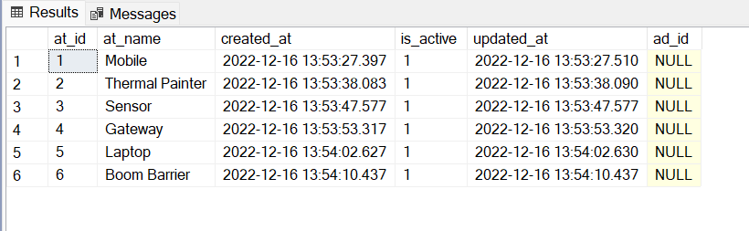

1. LISTING ALL ASSET TYPES

ENDPOINT: POST-> <http://localhost:9090/api/assetTypes>

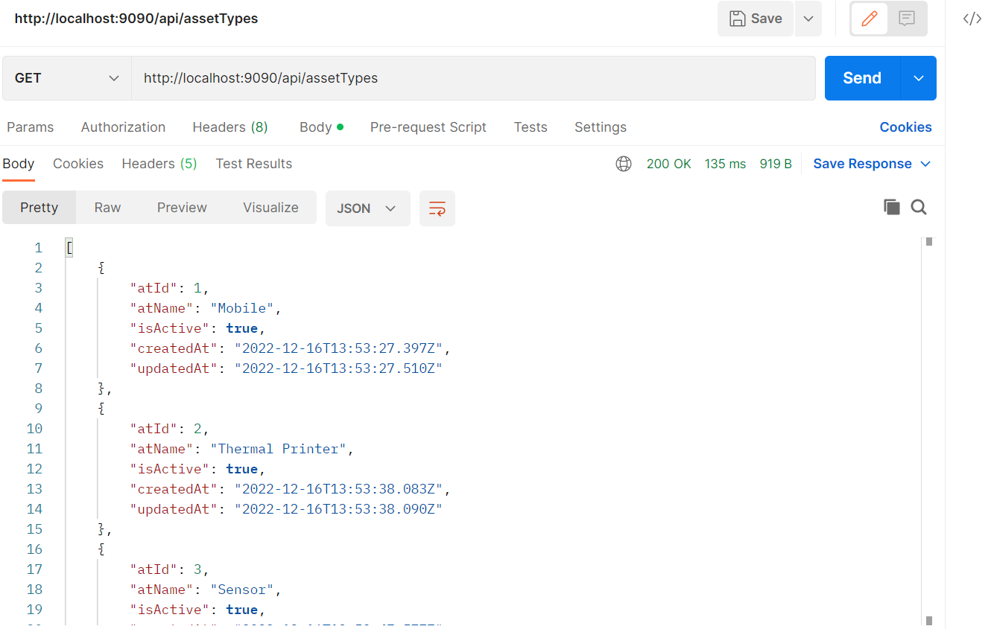

1. UPDATING AN ASSET TYPE BY ASSET TYPE ID

ENDPOINT: PUT-> <http://localhost:9090/api/assetTypes/2>

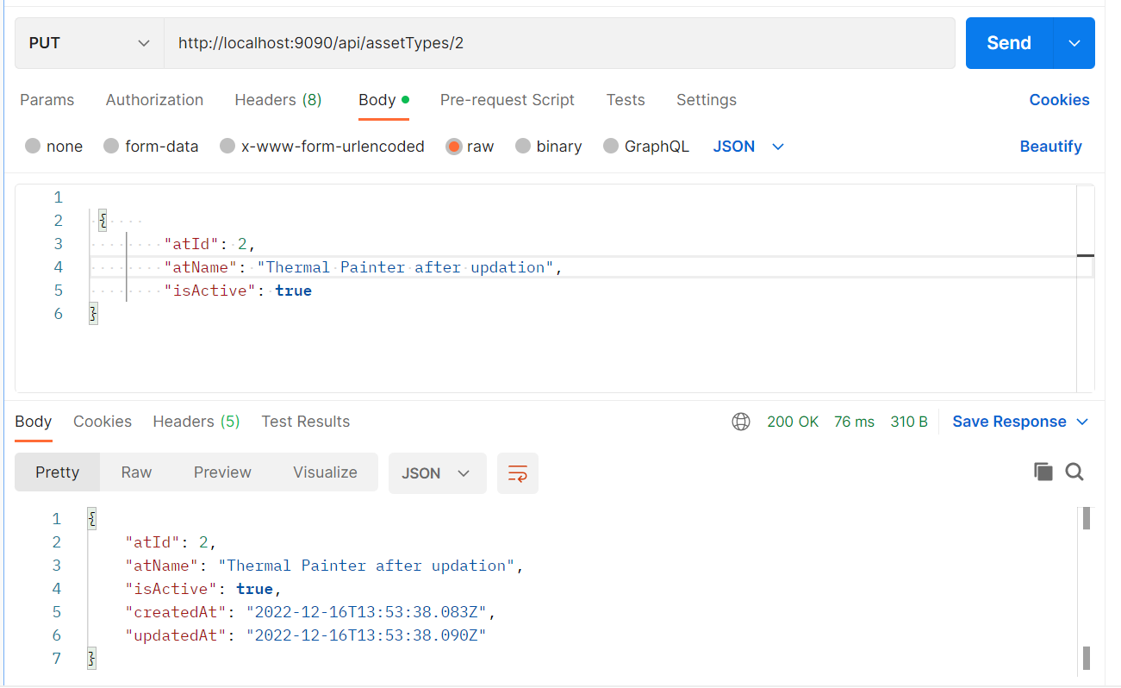

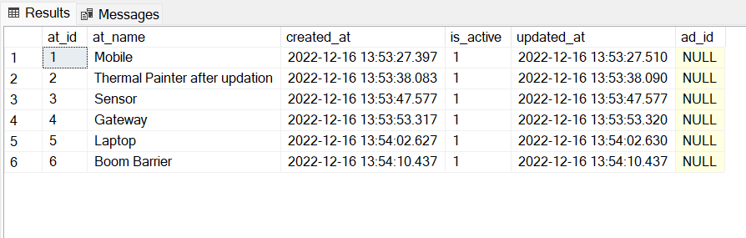

1. SEARCHING ASSET TYPE BY NAME

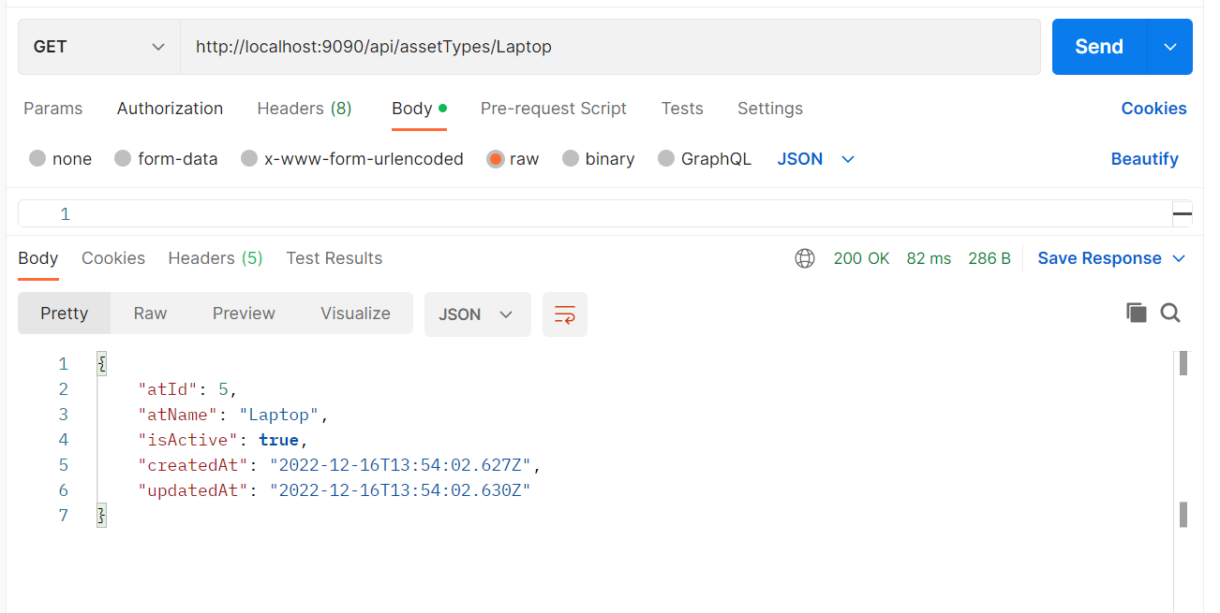

1. DELETING ASSET TYPE BY ID

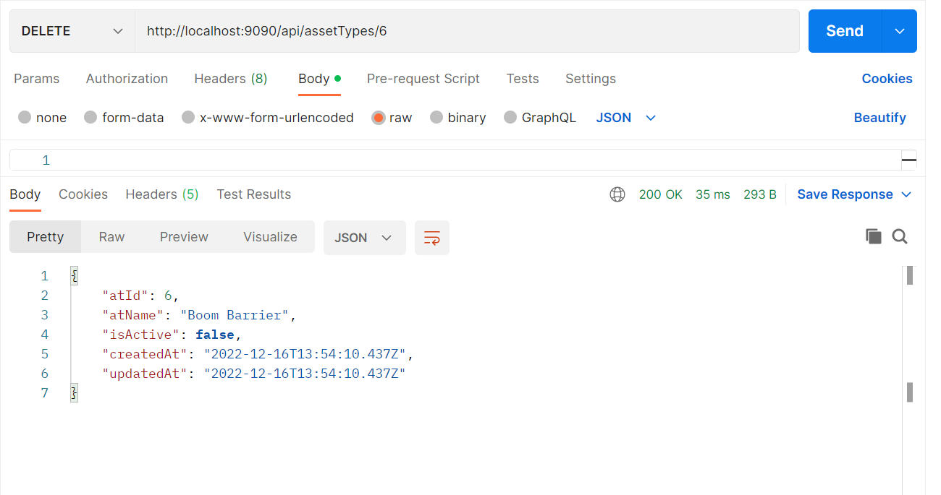

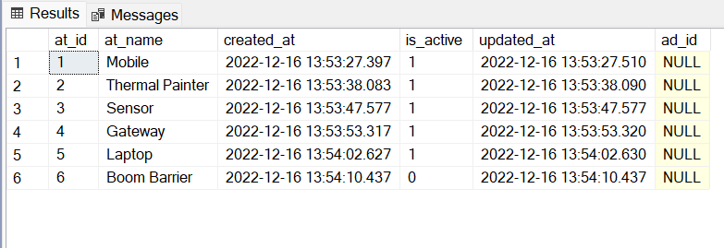

ASSET DEFINITION

1. ADDING NEW ASSET

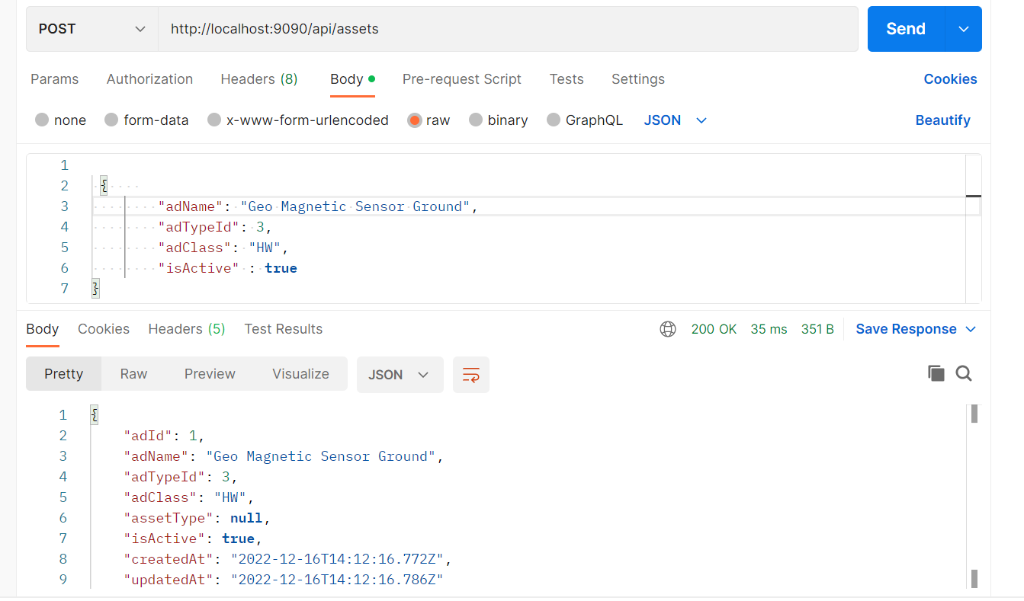

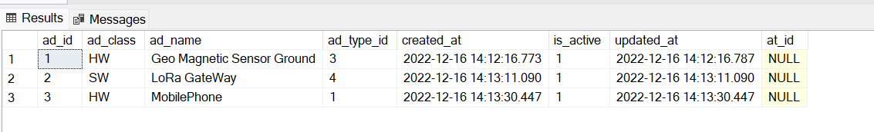

1. Updating an asset by ID

Changed AdClass to SW for AssetId = 2

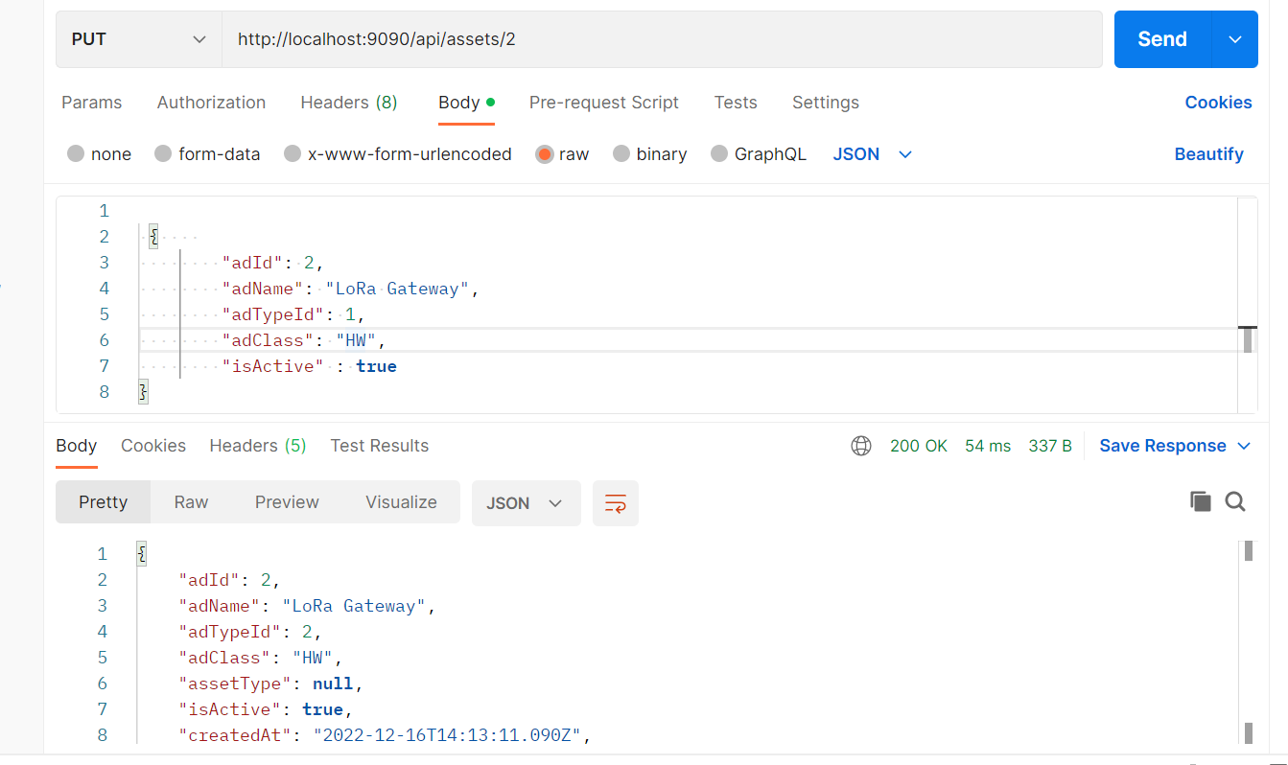

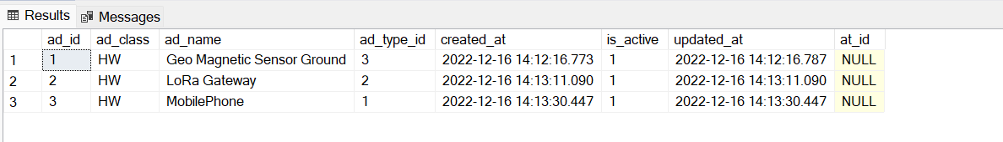

1. Listing all Assets

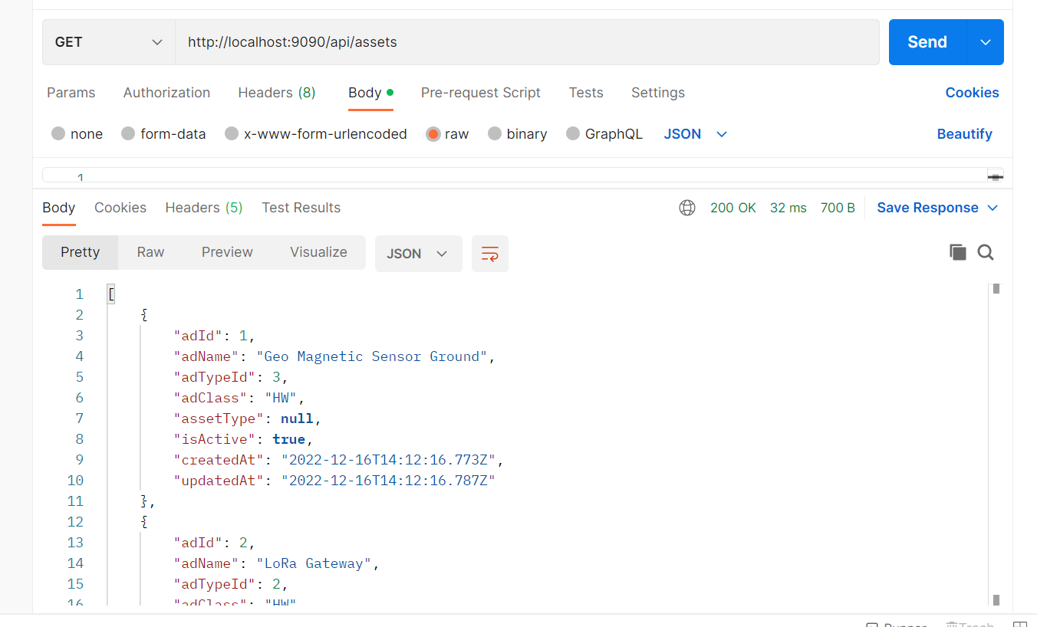

1. Searching an asset by name

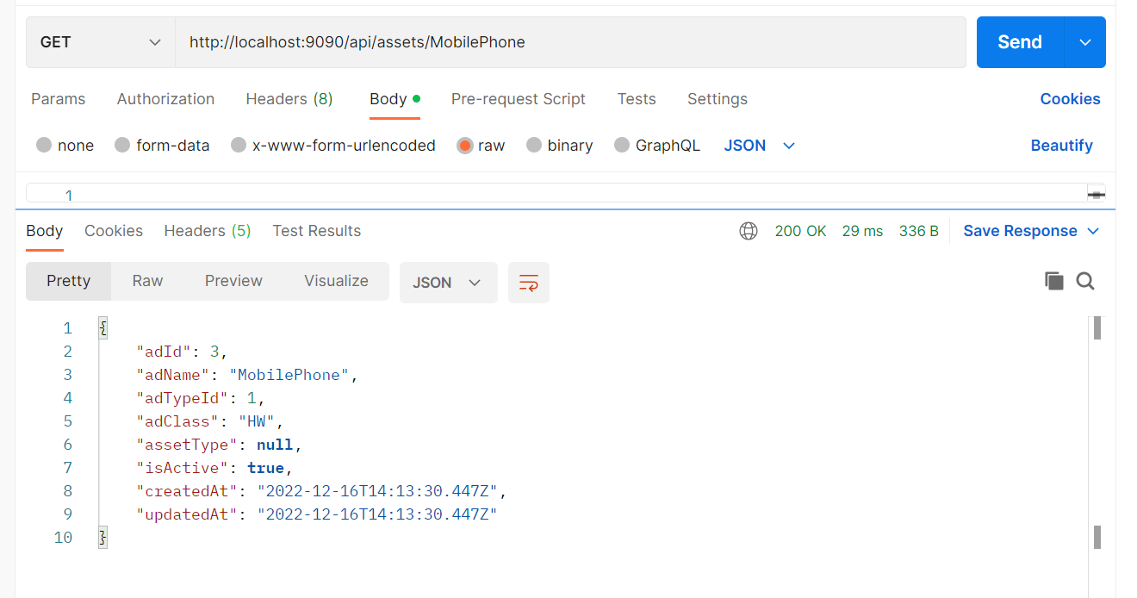

1. Deleting an asset

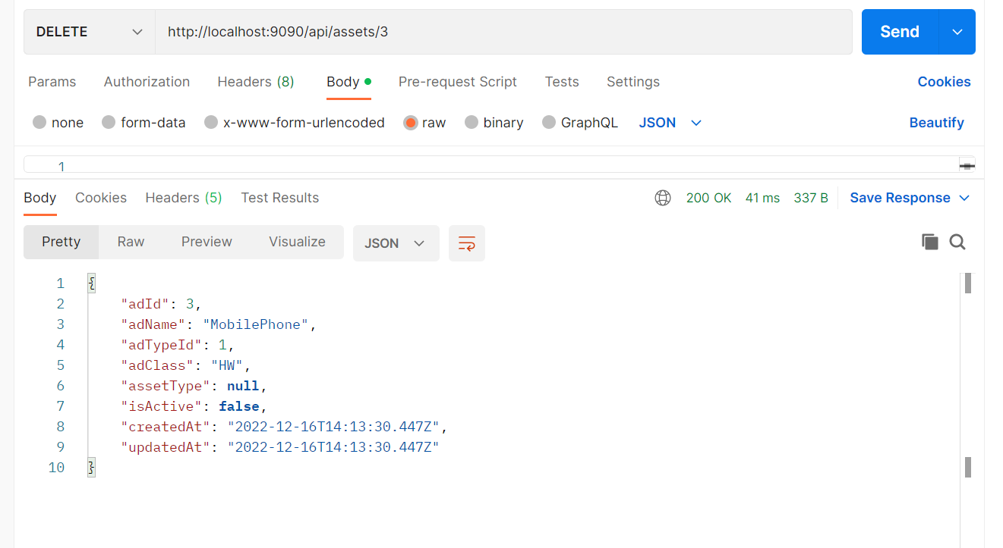

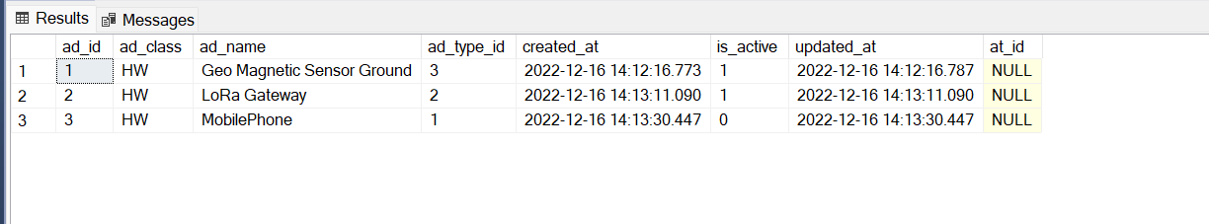

**MODULE – C**

**Vendor Creation: provide Vendor table with records**

1. Adding a new vendor

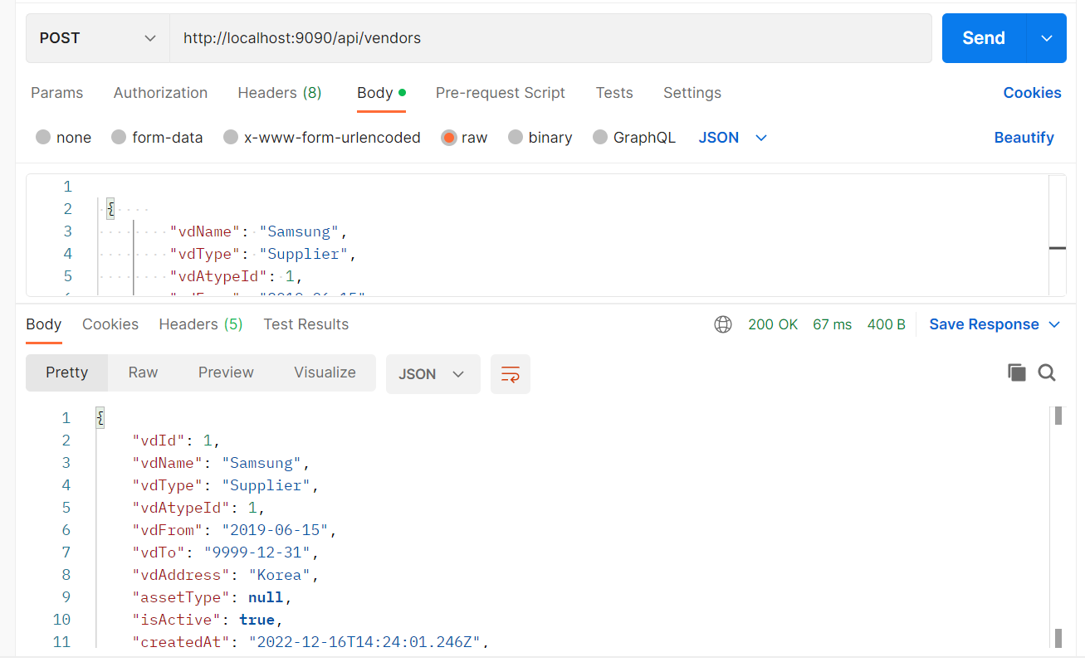

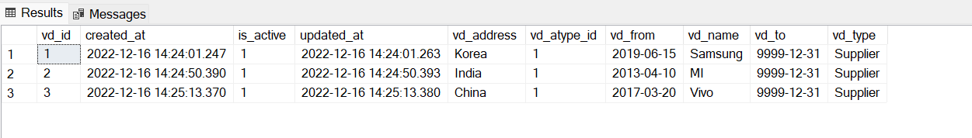

1. Updating a vendor by id

Changed Vendor address of vendor ID 3 from China to India

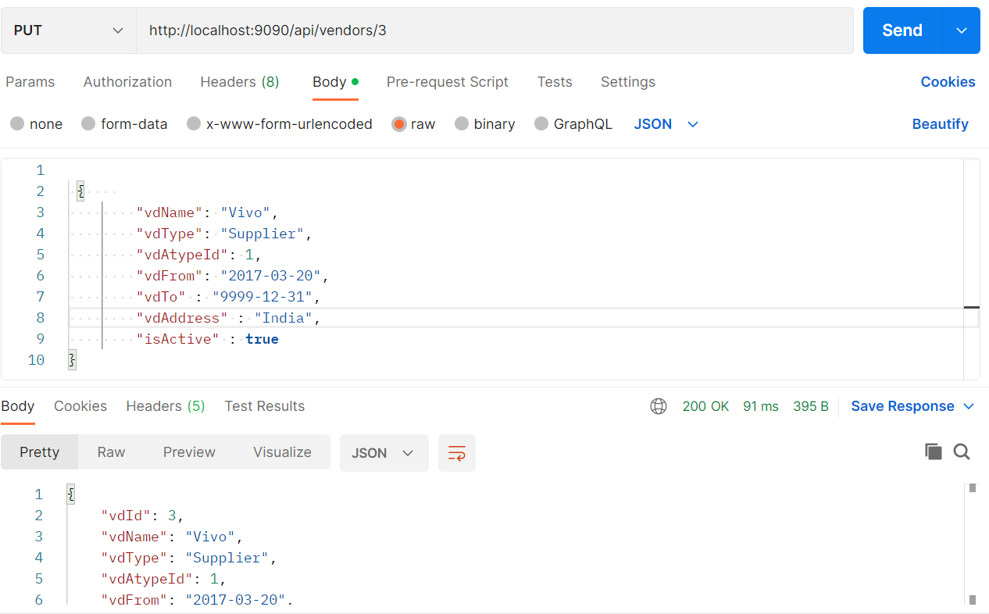

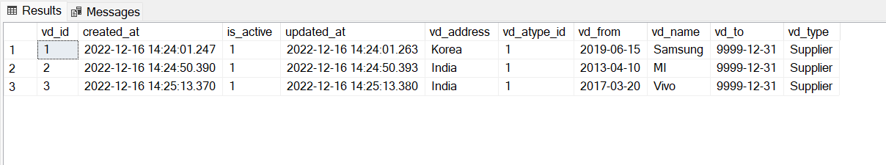

1. List all vendors

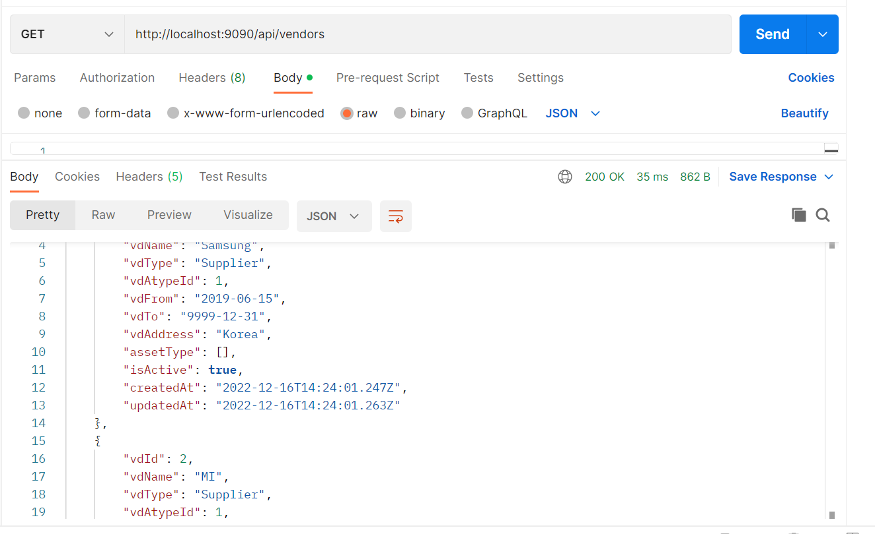

1. Search vendor by name

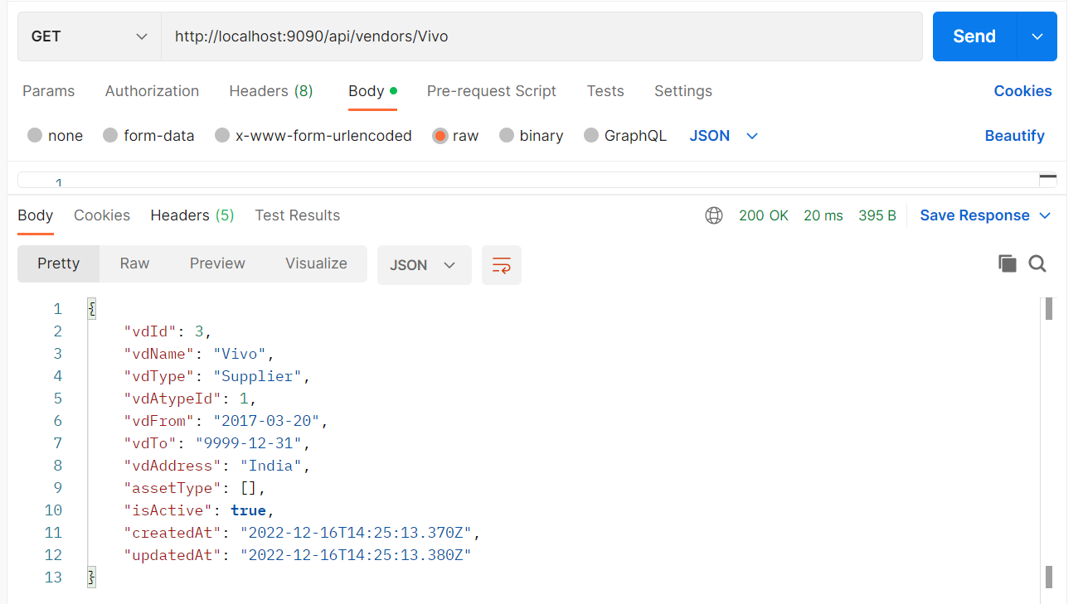

1. Delete a vendor

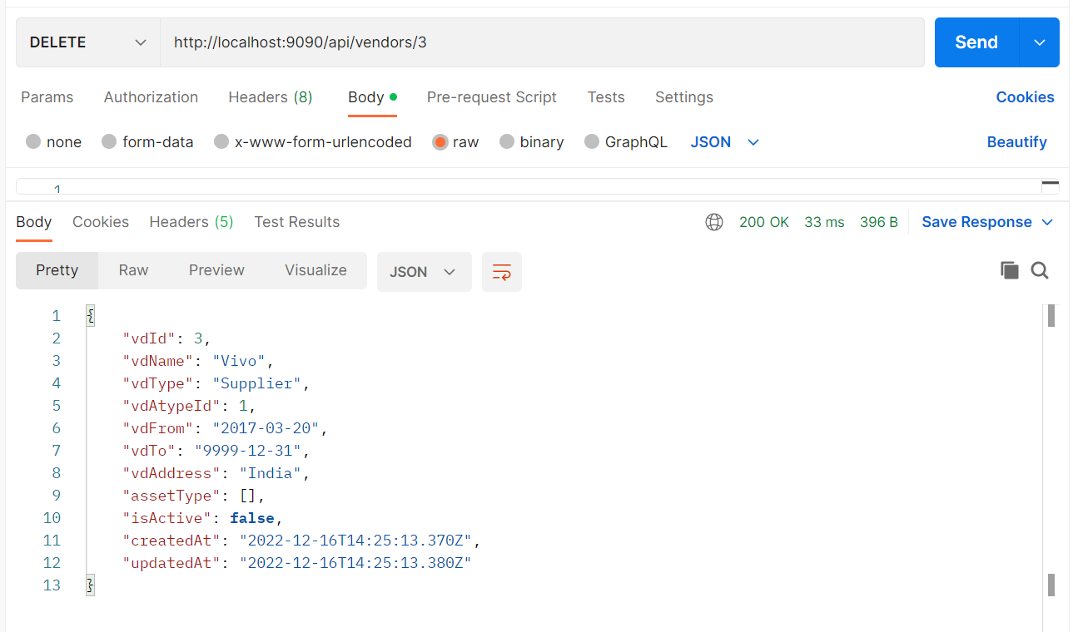

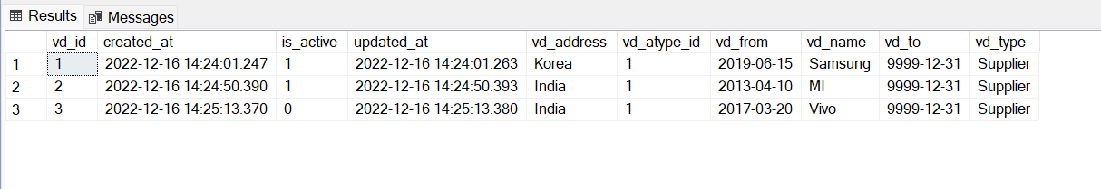

MODULE – D

Purchase Order Definition

1. Adding new purchase order

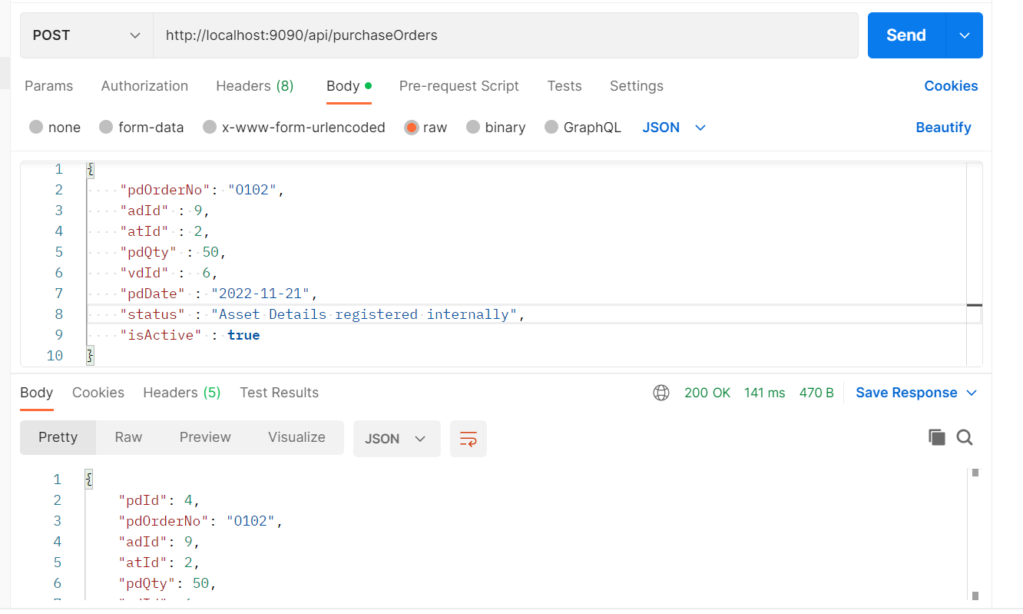

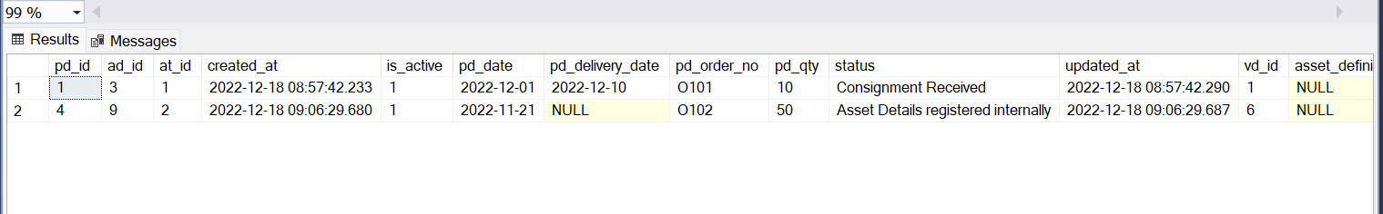

System should create a new record if the asset is available in the purchase order module and the status is 'Asset Details registered internally'.

One record automatically created while adding new purchase order

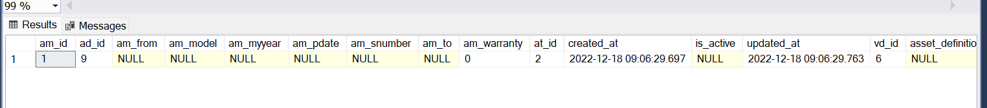

1. Updating a purchase order

Changed order quantity of pd_id = 4 from 50 to 30

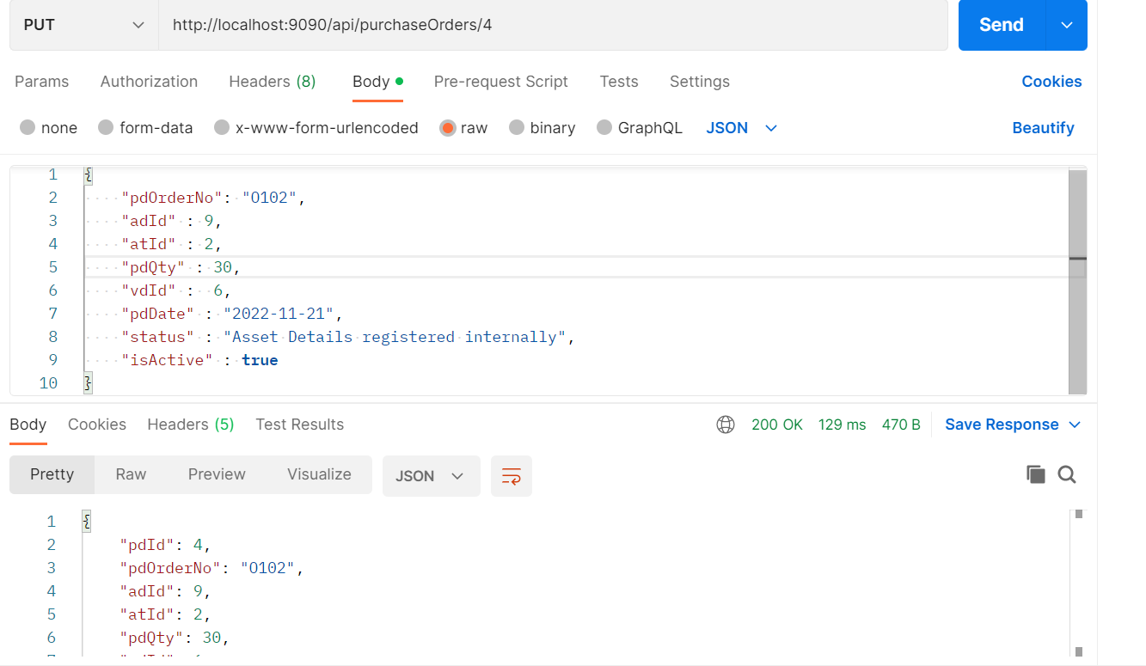

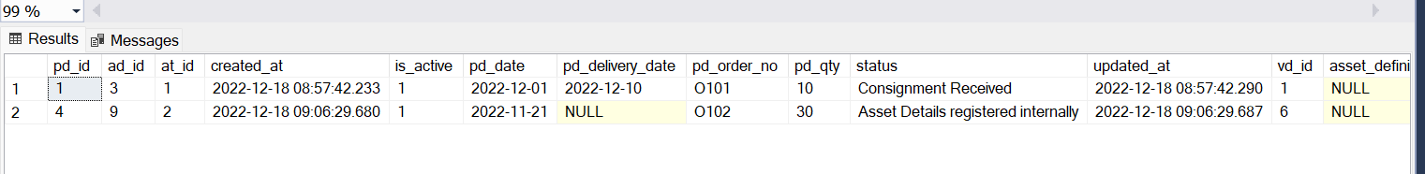

1. List all purchase orders

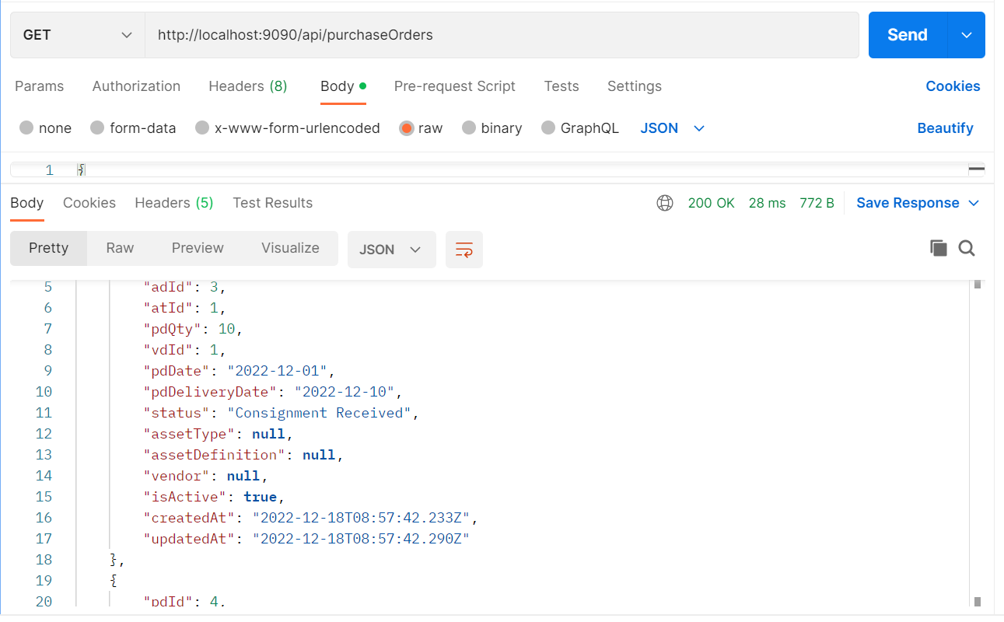

1. Delete a purchase id by id

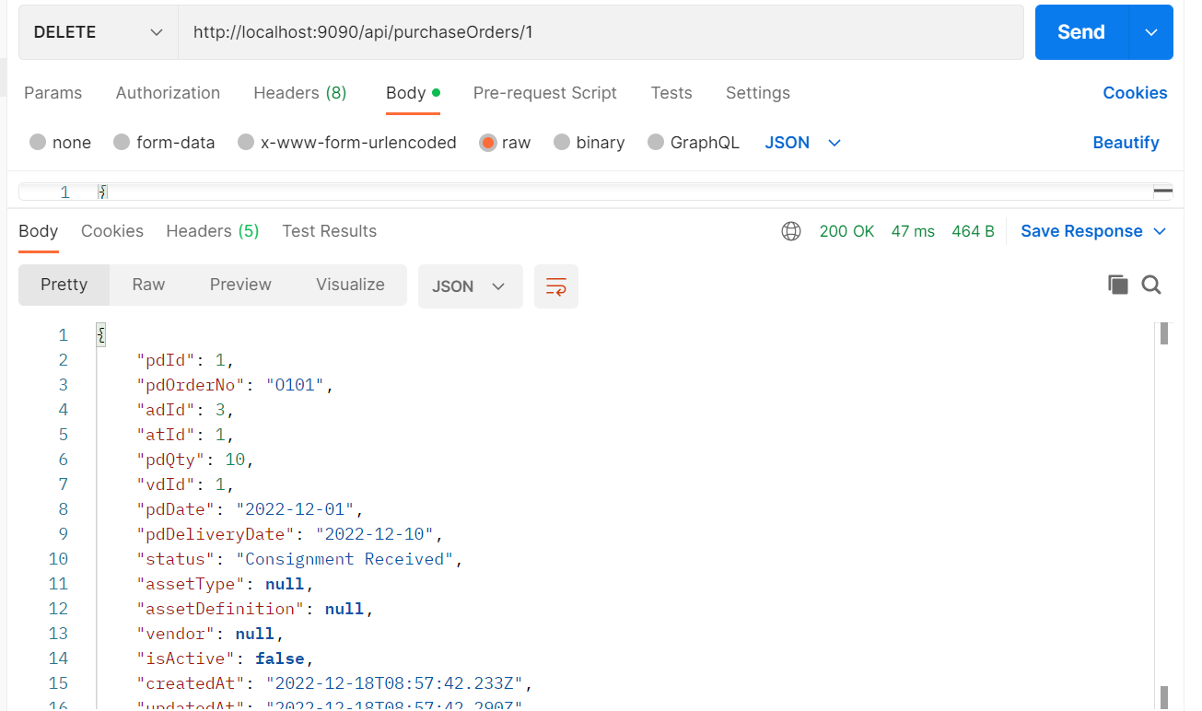



1. Search purchase order by id

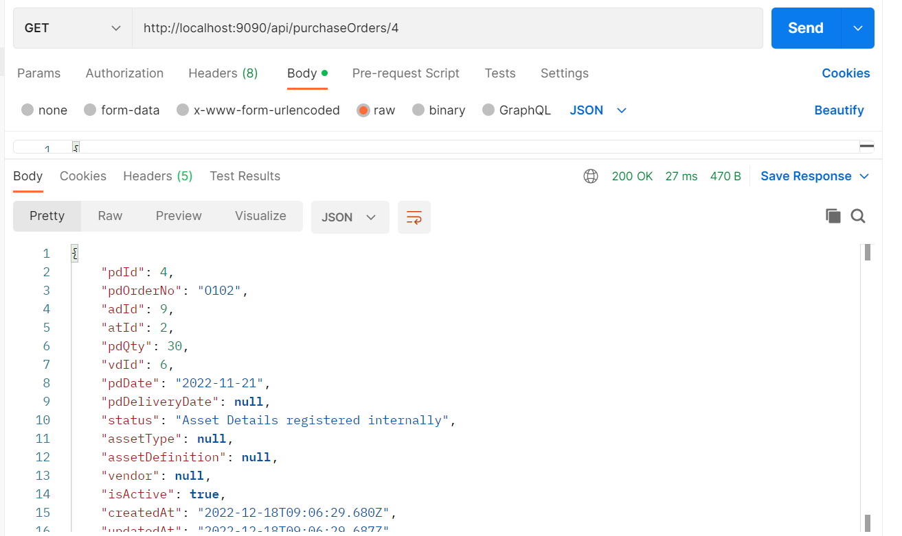

MODULE – E

Asset Master

1. Add new entry

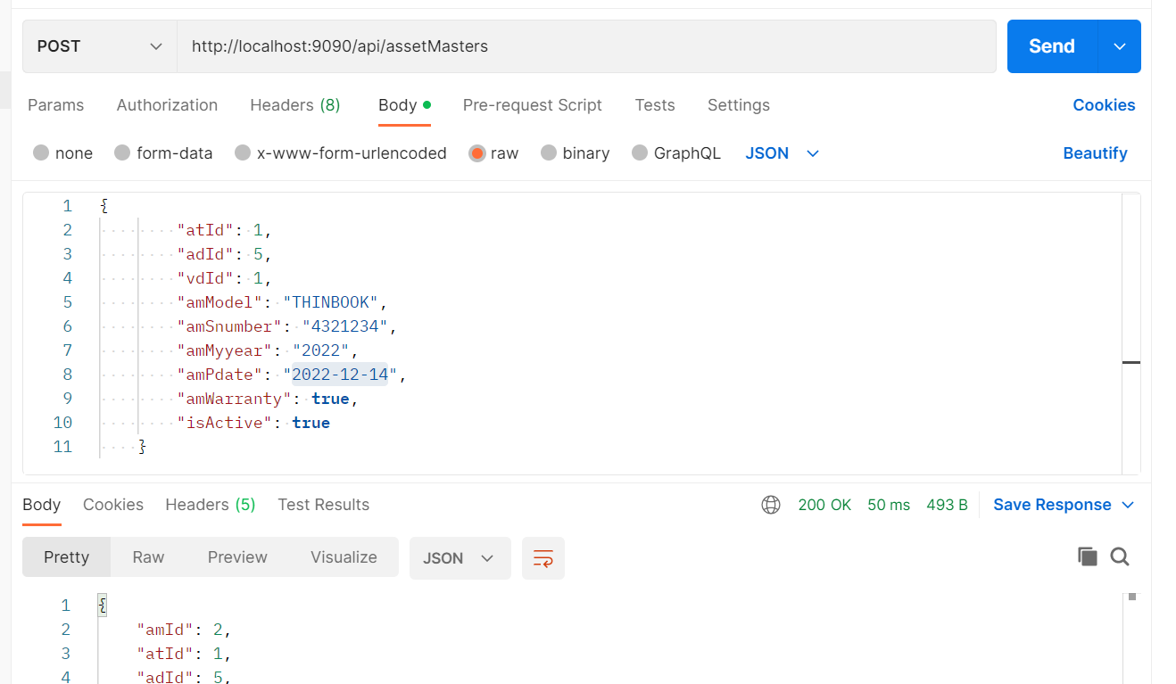

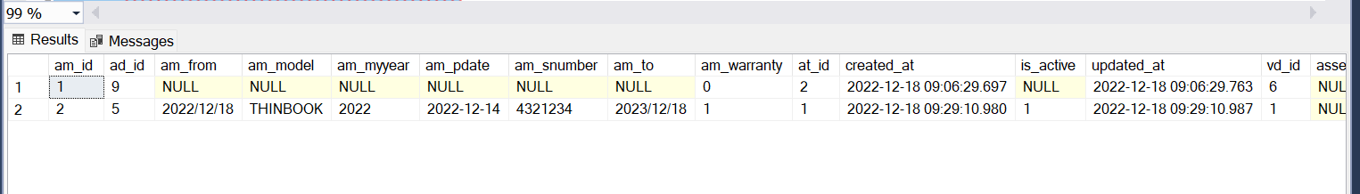

1. Update an asset master

Changed amModel column of am_id = 1 from THINBOOK to THINNOOK-101

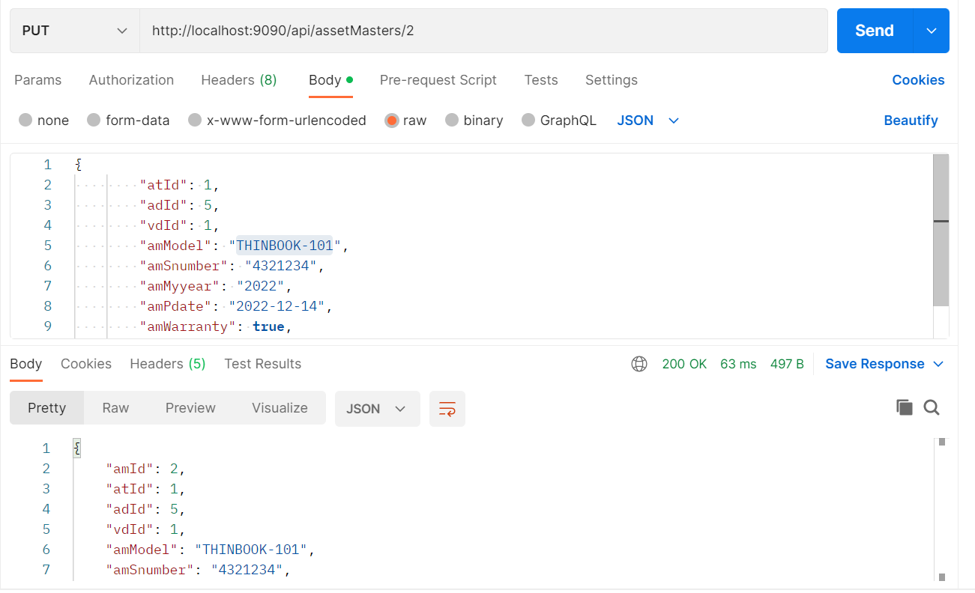

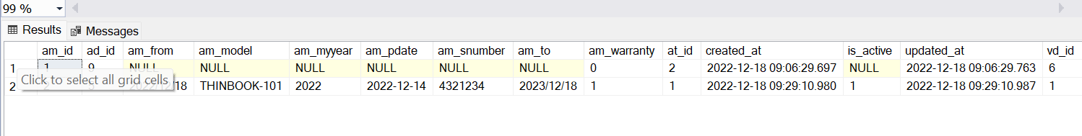

1. List all asset masters

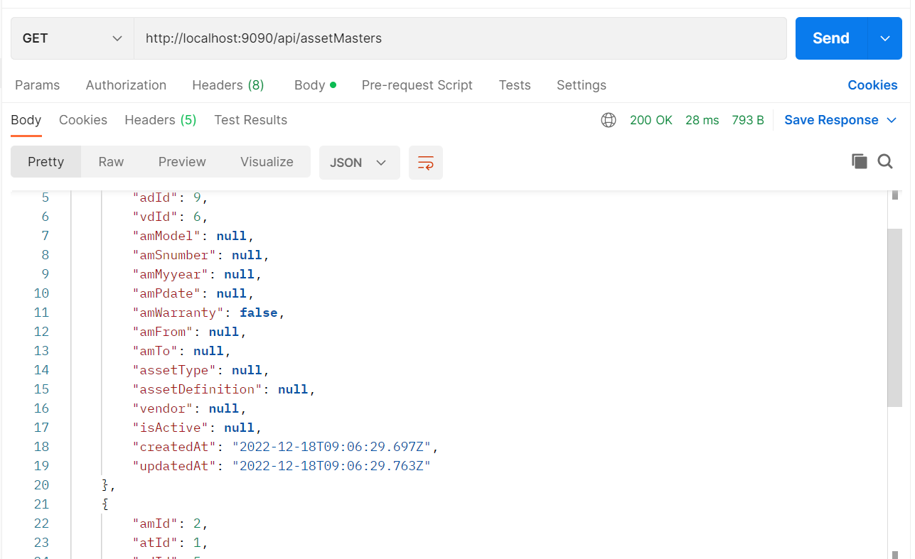

1. Delete an asset master by id

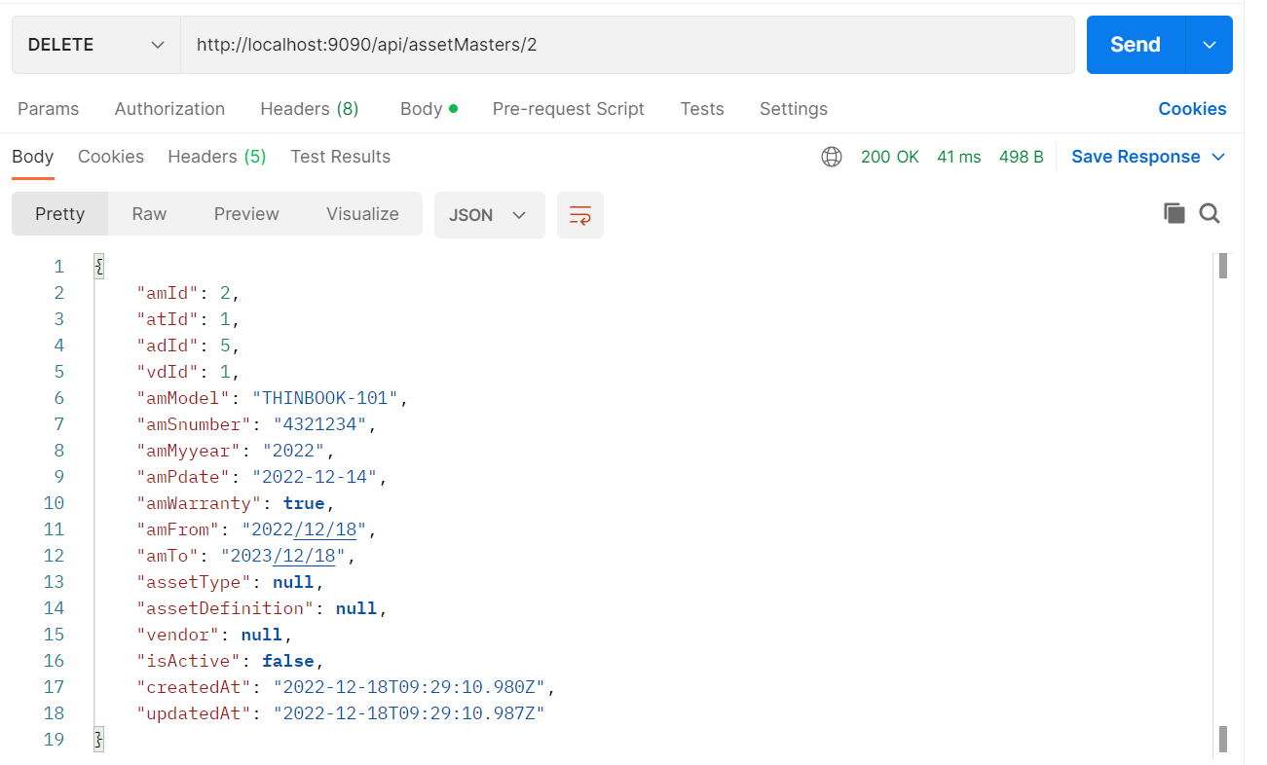

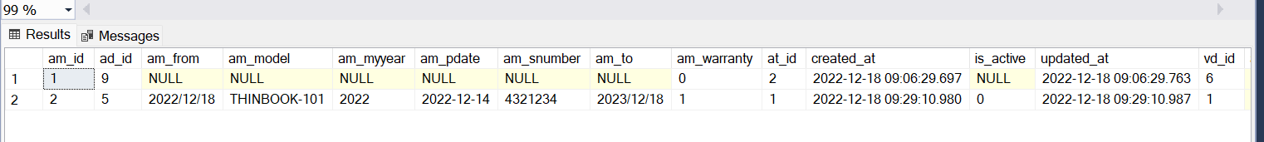

1. Search an asset master by ID

